|  |  |  |
| --- | --- | --- |
| **LAB221 Assignment** | **Type:** | **Short Assignment** |
| **Code:** | **J2.S.P0119** |
| **LOC:** | **50** |
| **Slot(s):** | **1** |

**Title**

Use PreparedStatement in JDBC

**Background Context**

A PreparedStatement is a special kind of Statement object with some useful features. Remember, you need a Statement in order to execute either a [query](http://tutorials.jenkov.com/jdbc/query.html) or an [update](http://tutorials.jenkov.com/jdbc/update.html). You can use a PreparedStatement instead of a Statement and benefit from the features of the PreparedStatement.

The PreparedStatement's primary features are:

* Easy to insert parameters into the SQL statement.
* Easy to reuse the PreparedStatement with new parameters.
* May increase performance of executed statements.
* Enables easier batch updates

**Program Specifications**

Create a program to update data using PreparedStatement in JDBC. The First, student should login MS SQL to create a database name “FU_DB” in MS SQL, then student creates a table name “Stocks” with fields:

* StockID: type is integer
* StockName: string
* Address: string
* DateAvailable: Date
* Note: string

Main functions described as below:

***Function details:***

1. Generate data and display on the dialog
2. Edit data and use JDBC to insert those data into “Stocks” table (must use PreparedStatement to update data)

***Expectation of User interface:***

The screen should be as:

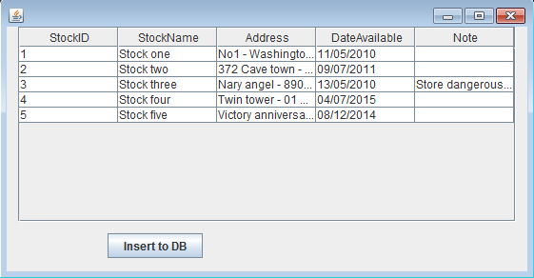

Data on the form is generated, when click “Insert to DB” button the data will be store in the database

**Guidelines**